**Stack Data Structure**

Stack is a linear data structure which follows a particular order in which the operations are performed. The order may be LIFO(Last In First Out) or FILO(First In Last Out).

Mainly the following three basic operations are performed in the stack:

* **Push:**Adds an item in the stack. If the stack is full, then it is said to be an Overflow condition.
* **Pop:** Removes an item from the stack. The items are popped in the reversed order in which they are pushed. If the stack is empty, then it is said to be an Underflow condition.
* **Peek or Top:** Returns top element of stack.
* **isEmpty:**Returns true if stack is empty, else false.
* **isFull:** Returns true if Stack is Full

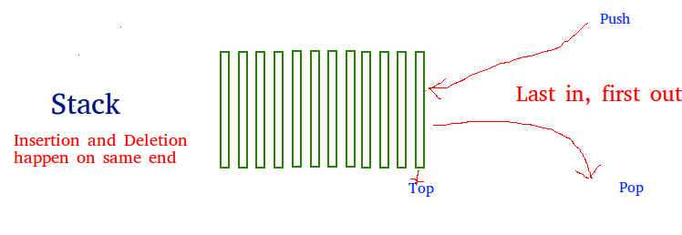

# Basic features of Stack:

1. Stack is an **ordered list** of **similar data type**.
2. Stack is a **LIFO**(Last in First out) structure or we can say **FILO**(First in Last out).
3. **push()** function is used to insert new elements into the Stack and **pop()** function is used to remove an element from the stack. Both insertion and removal are allowed at only one end of Stack called **Top**.
4. Stack is said to be in **Overflow** state when it is completely full and is said to be in **Underflow** state if it is completely empty.

# Usage:

1. Parsing
2. Expression Conversion (Infix to Postfix, Postfix to Prefix etc).

# Queue Data Structure

A Queue is a linear structure which follows a particular order in which the operations are performed. The order is First In First Out (FIFO). A good example of a queue is any queue of consumers for a resource where the consumer that came first is served first. The difference between [**stacks**](https://www.geeksforgeeks.org/stack-data-structure/)and queues is in removing. In a stack we remove the item the most recently added; in a queue, we remove the item the least recently added.

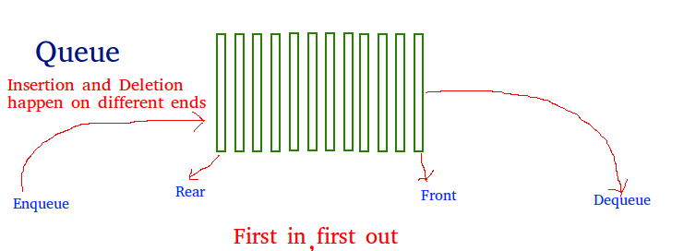

# Basic features of Queue

1. Like stack, queue is also an ordered list of elements of similar data types.
2. Queue is a FIFO( First in First Out ) structure.
3. Once a new element is inserted into the Queue, all the elements inserted before the new element in the queue must be removed, to remove the new element.
4. **peek( )** function is often used to return the value of first element without dequeuing it.

# Usage:

1. OS, Task Scheduling
2. Call Centers
3. Real Time Interrupts